**NEURAL NETWORKS AND DEEP LEARNING**

**ASSIGNMENT 2**

**NAME**: SRAVANI MANNURU

**STUDENT ID**: 700766162

**GITHUB LINK**: https://github.com/sravs2031/Neural-Networks-deep-learning-Assignment-2.git

**VIDEO LINK:** https://drive.google.com/file/d/1QHtcDKmelmygToLkRlznbeZlK_eVJKrR/view?usp=drive_link

1)

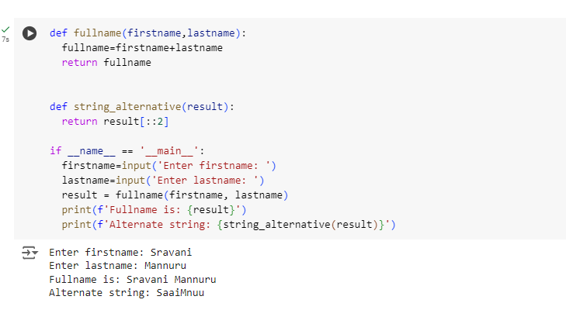

2)

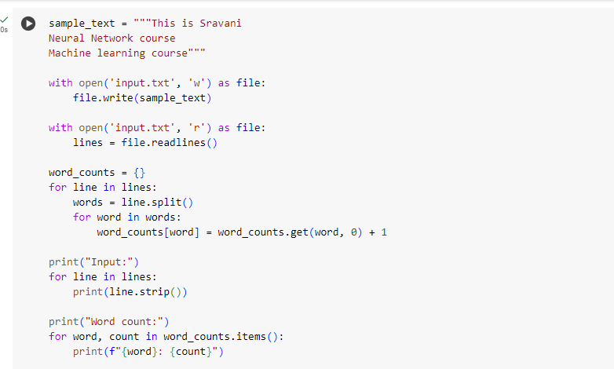

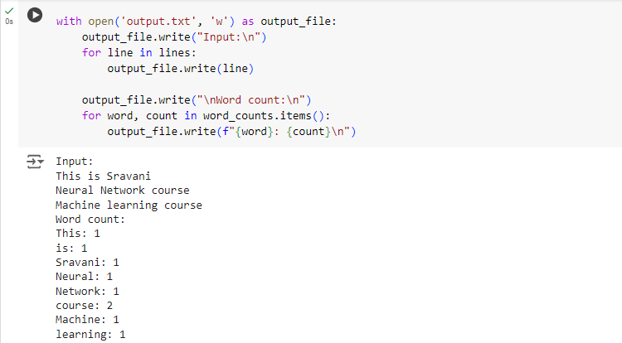

3)

